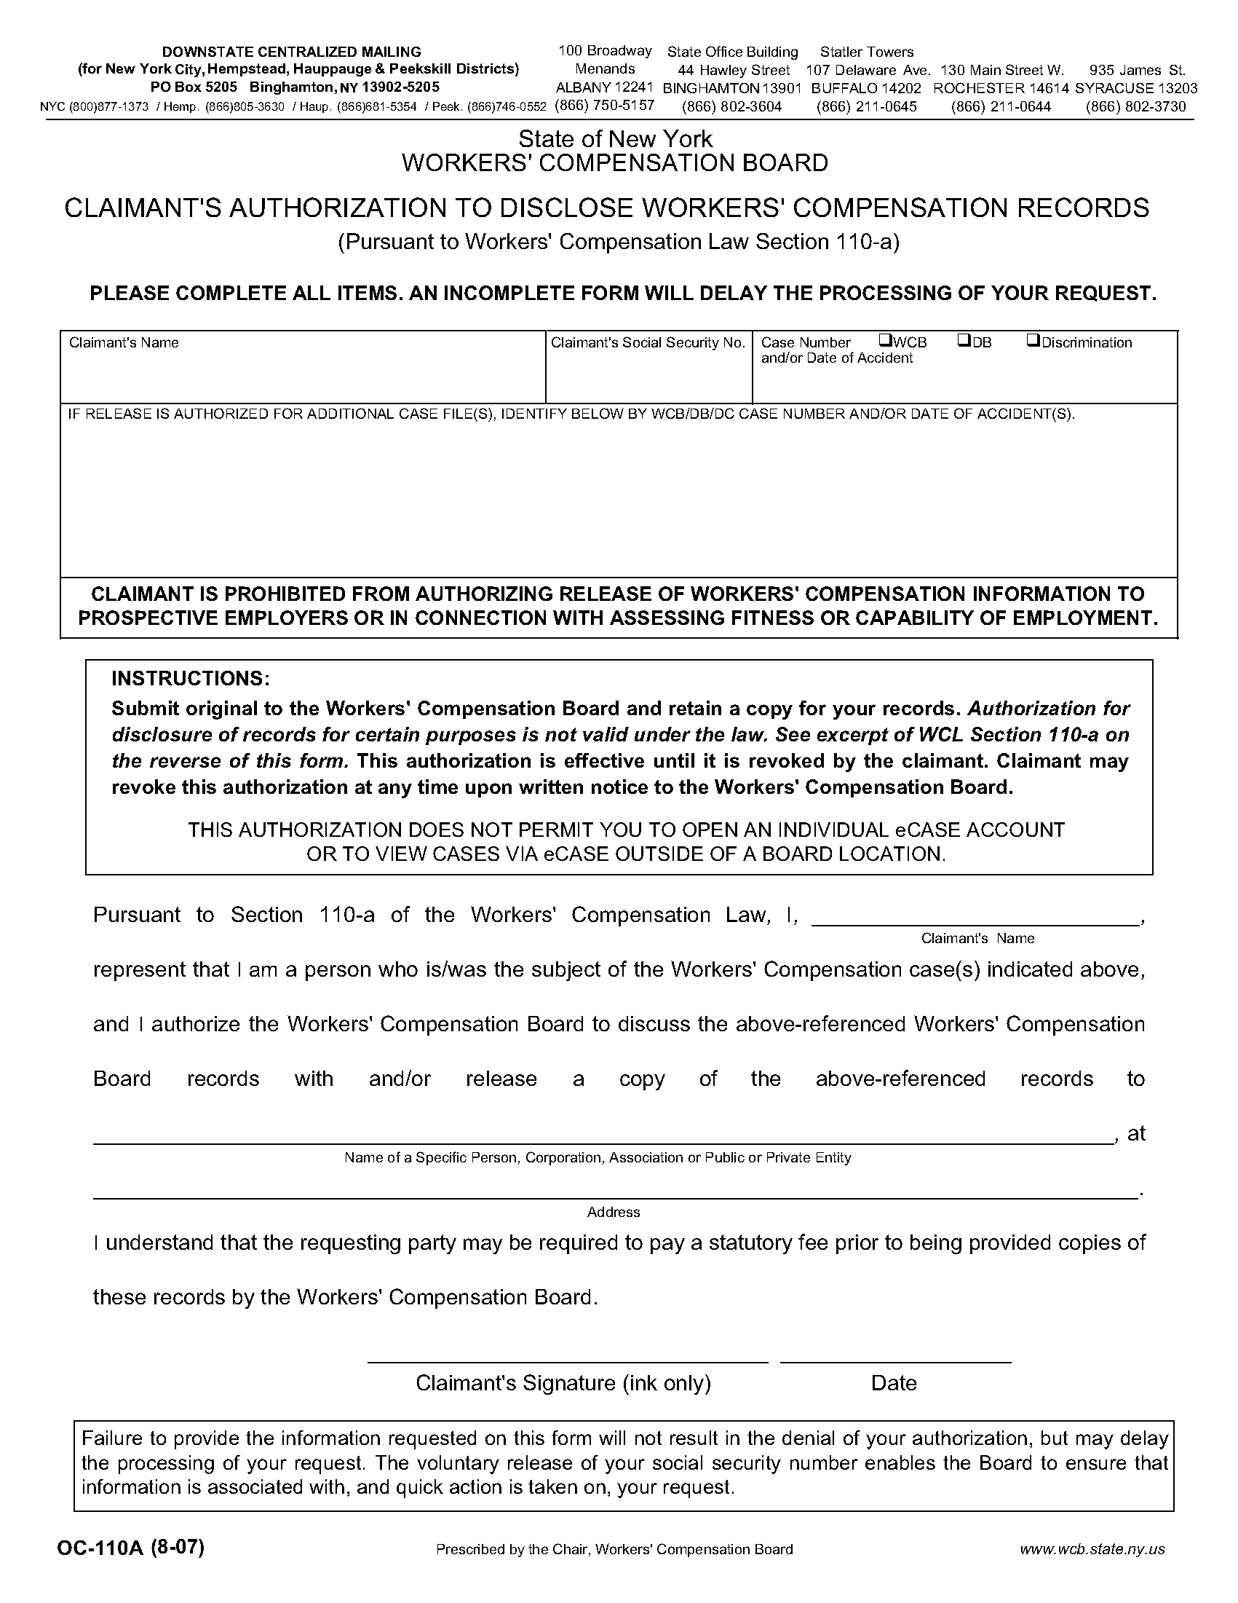

Janice Brown
Axiom Requisition Copy Service as agent of Foley, Baron, Metzger & Juip, PLLC
2869 Jolly Road, Okemos, MI 48864 (877) 886-5090 / Fax: (517) 886-4116
Janice Brown

121334546
Order No.: 01-29055-003

